Order Of Lenten Service

Opening Hymn: TLH 143 vs 1-5

Reading: Lent II

The History of the Passion of our Lord

Sermon Hymn: TLH 143 vs 6-10

Sermon Text: Daniel 3:8-18

A Test Of Faith

Prayer

Holy Communion

The Lord's Prayer

The Blessing

Closing Hymn: TLH 143 vs 11-15

* * * * * * * * * * * * *

Bible Study: Lambs: Wheat
Sheep: Romans 9:6-13

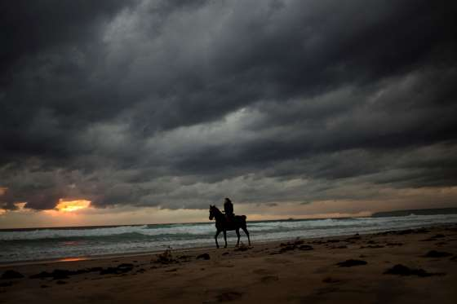

Approaching Storm

Water
Of
Life

18 February 2018

W A T E R O F L I F E

Independent Christian Church—Conservative Lutheran Doctrine

Worship Service: 9:30 a.m. Bible Study: 10:45 a.m.

Larry Cooper, Pastor E-Mail address:
111 N. Ridge Road lcooper@wateroflife.cc
Coon Valley, WI 54623 Web Site:
Phone: (608) 452-2105 www.wateroflife.cc

* * * * * * * * * * * * * * * * * * * * * * * * * * *

Sermon Text: Daniel 3:8-18

A Test Of Faith

* * * * * * * * * * * * * * * * * * * * * * * * * * *

Daniel 3:8 Wherefore at that time certain Chaldeans came near, and accused the Jews.
:9 They spake and said to the king Nebuchadnezzar, O king, live for ever.
:10 Thou, O king, hast made a decree, that every man that shall hear the sound of the cornet, flute, harp, sackbut, psaltery, and dulcimer, and all kinds of musick, shall fall down and worship the golden image:
3:11 And whoso falleth not down and worshippeth, that he should be cast into the midst of a burning fiery furnace.
:12 There are certain Jews whom thou hast set over the affairs of the province of Babylon, Shadrach, Meshach, and Abednego; these men, O king, have not regarded thee: they serve not thy gods, nor worship the golden image which thou hast set up.
:13 Then Nebuchadnezzar in his rage and fury commanded to bring Shadrach, Meshach, and Abednego. Then they brought these men before the king.
:14 Nebuchadnezzar spake and said unto them, Is it true, O Shadrach, Meshach, and Abednego, do not ye serve my gods, nor worship the golden image which I have set up?
:15 Now if ye be ready that at what time ye hear the sound of the cornet, flute, harp, sackbut, psaltery, and dulcimer, and all kinds of musick, ye fall down and worship the image which I have made; well: but if ye worship not, ye shall be cast the same hour into the midst of a burning fiery furnace; and who is that God that shall deliver you out of my hands?
:16 Shadrach, Meshach, and Abednego, answered and said to the king, O Nebuchadnezzar, we are not careful to answer thee in this matter.
:17 If it be so, our God whom we serve is able to deliver us from the burning fiery furnace, and he will deliver us out of thine hand, O king.
:18 But if not, be it known unto thee, O king, that we will not serve thy gods, nor worship the golden image which thou hast set up.
* * * * *
1 Peter 5:8 Be sober, be vigilant; because your adversary the devil, as a roaring lion, walketh about, seeking whom he may devour:
